**Dissolve shaders guider**

**shaders usage**

In the shaders folder you have 4 different materials each one contains the shader so all you need to do is grab the material you want to the object you want to have the material. Each one of the materials dissolve in a bit different way as you can see in the videos in the unity asset store page of mine. After you add the material to the object there are a few parameters you can change in the inspector.

**Parameters explanation:**

**edge color:** one of the colors in the edge that are seen when doing the animation.

**edge color 2:** the second color that is combined with the first edge color

**visible amount:** with this one you don’t really need to touch, this one is how much of the effect is going on and the script is moving this parameter from 1 to 0 and from 0 to 1.

**Base texture:** probably the object you are putting the effect on has a texture so just put your texture in there and it will be the texture of the object.

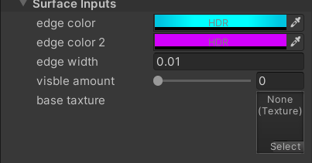

**Script usage**

The scripts are the ones that doing the animation itself and they are found in the scripts folder. There are two script:  
**1.** "StartAnimationScript" you can put on an empty gameObject and put in the monkey renderer variables to 3 different objects in the empty field. On this one i less recommend to use I more recommend on the second one because its better and easier to set up.

**2.** "StartAnimationScriptForOneObject" all you need to do with this script is to put on the object you want to have the effect but there are a few parameters you can change to your liking.

**\*remember to put the material along with the script on the object you want to have the effect.**

**Parameters explanation:**

**Key To Start Dissolve:** just change to the key you want to make the dissolve effect when pressed.

**Key To Start Appear:** this key is to make the object appear again after pressed (if you don’t want at all this effect you can change it to none)

**Dissolve Rate:** when making the object more visible or the opposite this variable controls at how much to do it every time more visible (when calling the function at how much to make the object more visible or the opposite)

**Refresh Rate:** after how much time to call again the function that makes the object more visible or the opposite.

**\* the last two parameters at easy words are controlling the speed of the effect. In the next page is the picture of the parameters.**

